Assignment 5: Assignments on Functions

Name: Rajesh Mahendra Anerao
Sub: Python for Engineers (PFE)
Roll No.: 15
Branch: CSE-Data Science Engineering

Q 1.
- Problem Statement: Function to check if a number is even or odd
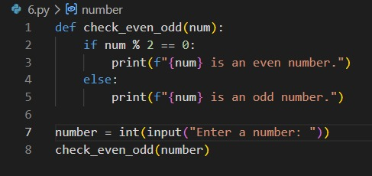
Output:
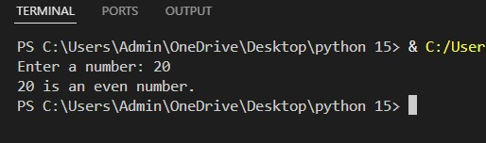
Conclusions:
Determines whether a number is even or odd by checking divisibility by 2. It introduces basic conditional logic and arithmetic operations used frequently in programming tasks.

Q 2.
- Problem Statement: Function to find the maximum of two numbers
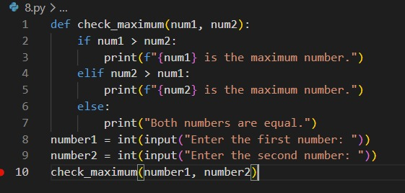
Output:
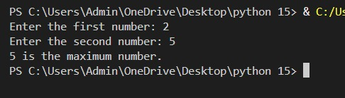
Conclusions:
Compares two numbers and returns the greater one. It demonstrates decision-making using conditions, which is essential for solving problems involving comparisons and logical operations.

Q 3.
Problem Statement: Function with keyword arguments
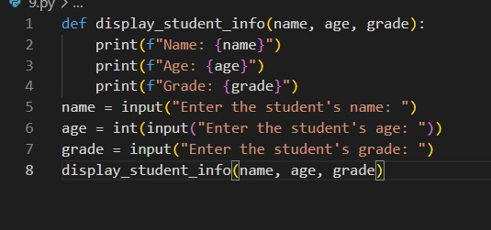
Output:
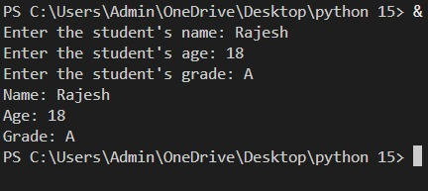
Conclusion:
Allows passing arguments by name instead of position. This improves readability, flexibility, and reduces errors when working with functions that have multiple parameters.
Q 4.
Problem Statement: Function with default arguments
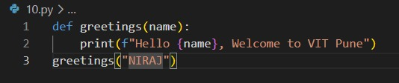
Output:
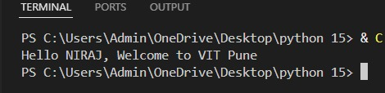
Conclusion:
Provides default values for parameters if no arguments are given. This makes functions easier to use and more flexible by reducing the need to pass all values explicitly.

Q 5.
Problem Statement: Function to Find the Factorial of a Number Using Recursion
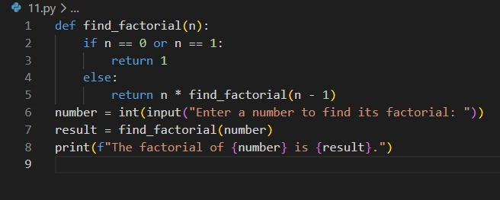
Output:
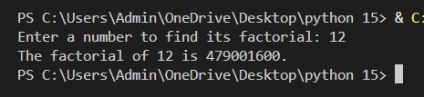
Conclusion:
Calculates factorial using recursion by breaking the problem into smaller steps until reaching a base case. It helps understand recursive thinking and function self-calling behavior.

Q 6.
Problem Statement: Function to Find the Sum of the Digits of the Number Recursively
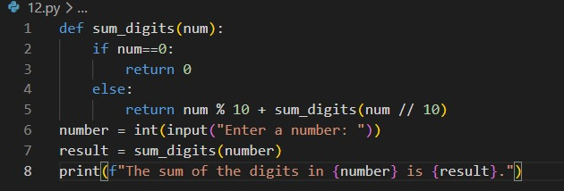
Output:
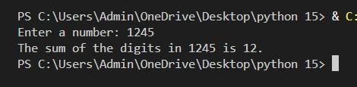
Conclusion:
Uses recursion to add digits of a number by repeatedly extracting the last digit. It simplifies problems involving repeated breakdown of numbers into smaller parts.
Q 7.
Problem Statement: Create a function named count vowels that accepts a string and returns the number of vowels in the string.
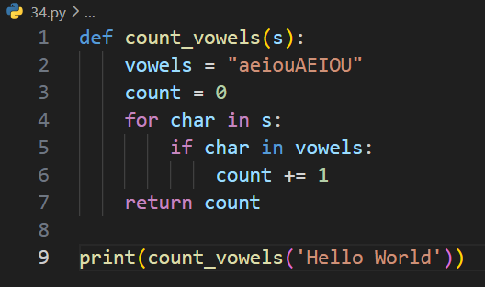
Output:
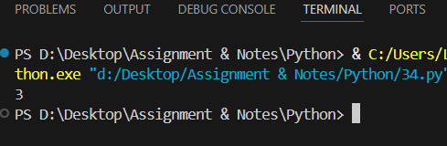
Conclusion:
Counts vowels in a string by iterating through characters and checking conditions. It builds understanding of string handling and basic text processing techniques.

Q 8.
Problem Statement: Write a function greet user that takes a user’s name as a parameter and prints a personalized greeting message.
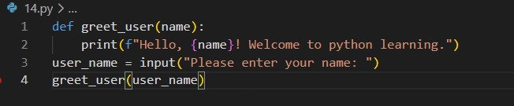
Output:
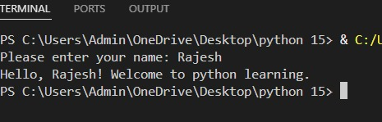
Conclusion:
Accepts a user’s name and prints a personalized message. It demonstrates how functions can interact with users and produce dynamic, customized outputs.
Q 9.
Problem Statement: Given a sequence of integers that end with a 00. Print the sequence in reverse order. Don't use lists or other data structures. Use the force of recursion instead.
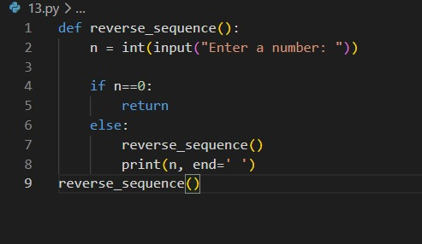
Output:
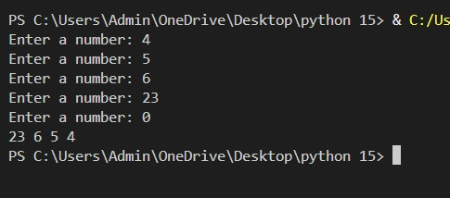
Conclusion:
Reverses a sequence using recursion without extra storage. It prints values during function return, illustrating recursive call flow and stack behavior effectively.

